MEDICAID TRANSPORTATION

If you are interested in…

- Saving money on gas
- Saving on the wear and tear of your vehicle
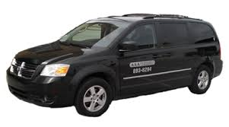
- Having a relaxing trip to therapy instead of a stressful drive
at NO COST to you

then

Call: 1-800-245-2826

TO CHECK YOUR ELIGIBILITY

